Instagram Login Module – Test Report
Module Name: Login Page - Functional & UI Test Cases
Test Case ID: TC_LOGIN_001
Tester Name: Aman Sevak
Application: Instagram Mobile App
Test Case Description: To validate the functionality of the Instagram login workflow on the mobile application using valid and invalid credentials.
Prerequisites:
- Instagram application installed
- Stable internet connection
- Registered test username (all_relation.in_)
- Correct and incorrect test passwords
Environment Information: OS: Android 13 | Device: Android Mobile Phone | Application: Instagram Mobile App

Scenario ID: 1a
Scenario: Login with valid credentials
Test Steps:
- Open Instagram app
- Enter username (all_relation.in_)
- Enter correct password
- Click Log in
Screenshots:
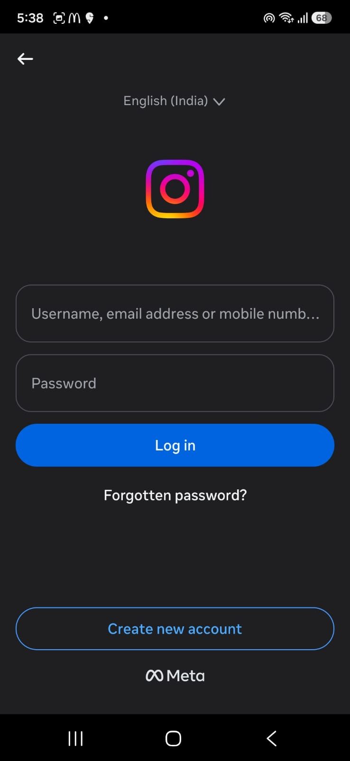
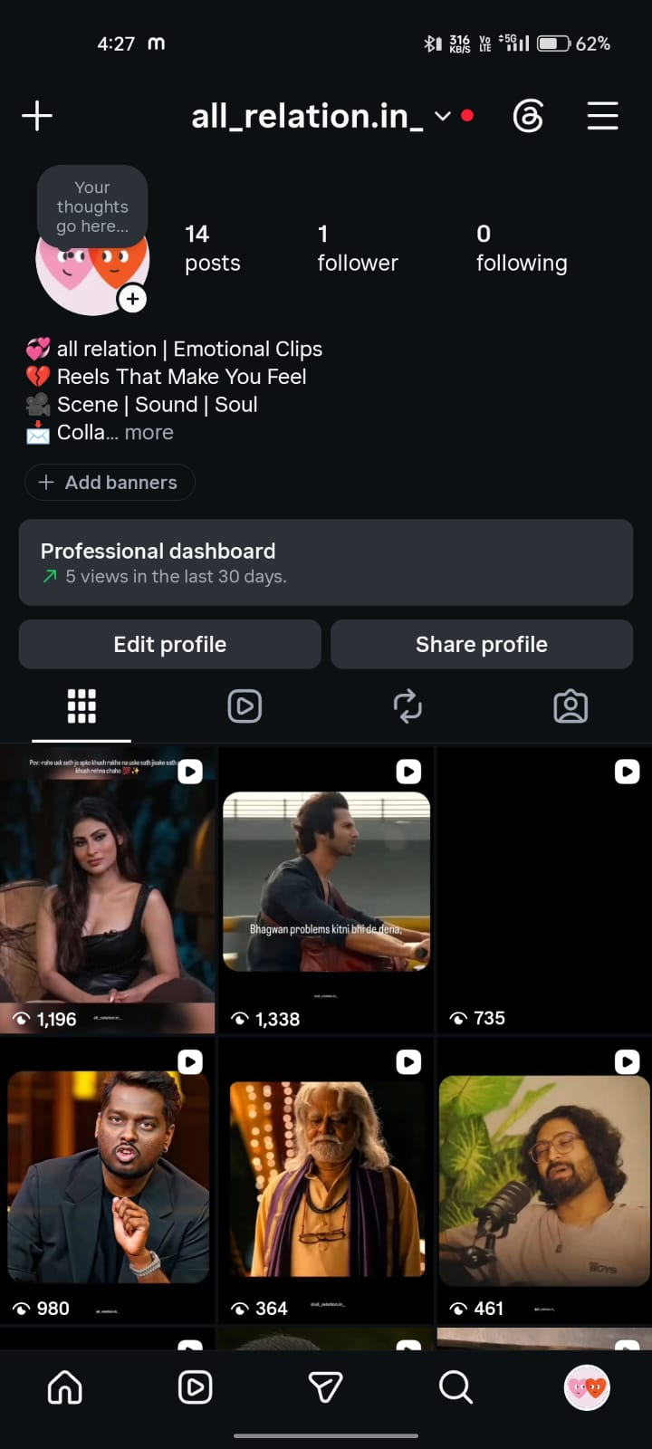

Scenario ID: 1b
Scenario: Login with incorrect password
Test Steps:
- Open Instagram app
- Enter username (all_relation.in_)
- Enter incorrect password
- Click Log in
Screenshots:
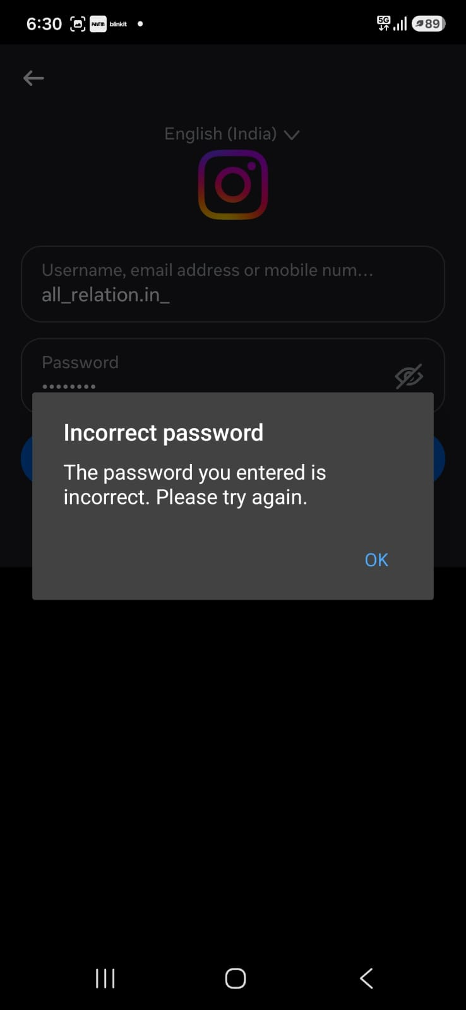

Summary of Test Results
Total Test Cases: 2
Passed: 2
Failed: 0
Pass %: 100%

Conclusion and Recommendations
Pass Rate: 100% — Login module functioning as expected.
Both test scenarios passed successfully. The Instagram login feature correctly authenticates users with valid credentials and displays an appropriate error message when an incorrect password is entered. No functional issues were observed during this round of testing.

Bug Reports
No bugs were found during this testing cycle — both scenarios (valid login and invalid password) produced the expected results.

